Pins for connectors

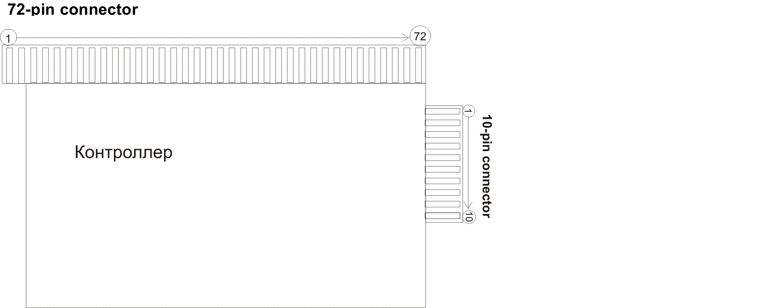

Pins for 72-contact connector

72-pin connector
pin | Side A | Side B
1
2 | SPEAKER L
3 | SPEAKER R | GND
4 | HOLD1 SW | BILL ACCEPTOR
5 | HOLD 2 SW
6 | HOLD 3 SW
7 | HOLD 4 SW
8 | HOLD 5 SW
9 | START SW
10 | BET ONE SW
11 | SELECT GAME SW
12 | AUTO START
13 | SERVIS
14 | MAXBET SW
15 | INFO SW
16 | FRONT DOOR SW
17 | BACK DOOR SW
18
19
20 | STATISTIC SW (short)
21 | COLLECT SW
22
23 | BILLS COUNTER | SELECT GAME LAMP
24 | DROP COUNTER | WBA LED
25 | REMOTE COUNTER | UPPER LAMP BLUE
26 | GAMES COUNTER | UPPER LAMP WHITE
27 | HANDPAY COUNTER | WIN COUNTER
28 | TOKEN COUNTER | BET COUNTER
29 | HOLD 1 LAMP | BET ONE LAMP
30 | HOLD 2 LAMP | MAXBET LAMP
31 | HOLD 3 LAMP | COLLECT LAMP
32 | HOLD 4 LAMP
33 | HOLD 5 LAMP | AUTO START LAMP
34 | START LAMP | INFO LAMP
35
36 | GND | GND

Side А (the top) on the connector (block terminal), which is connected to the controller on 72 pin, can be determined by means of biggest quantity of appropriate wires. On the side B – lesser quantity of wires.

Pins for 10-contact connector

10-pin connector
pin | Side A | Side B
1 | GND | GND
2 | GND | GND
3 | +5v | +5v
4 | +5v | +5v
5 | +12v | +12v
6 | +12v | +12v
7
8
9 | GND | GND
10 | GND | GND

Switching on the ECS

1) 2 for 10 pin. Standard power adaptor with computer.
2) 2 for 2 pin. Power for the embedded computer system is switched from the standard power adaptor.
3) switching of the bill acceptor see the paragraph (pinout of the embedded computer system).
4) switching the monitors see the picture №1. I – medium monitor. II – low one, III-top one. (low monitor should be connected by means of adaptor dvi on vga) monitors aiser w203
5) initialization of the machine (at the switched off machine 1) open the door (pull the pinswitch) 2) turn the key (operator’s) and hold 3) press and hold the button Service.
4) power on the machine
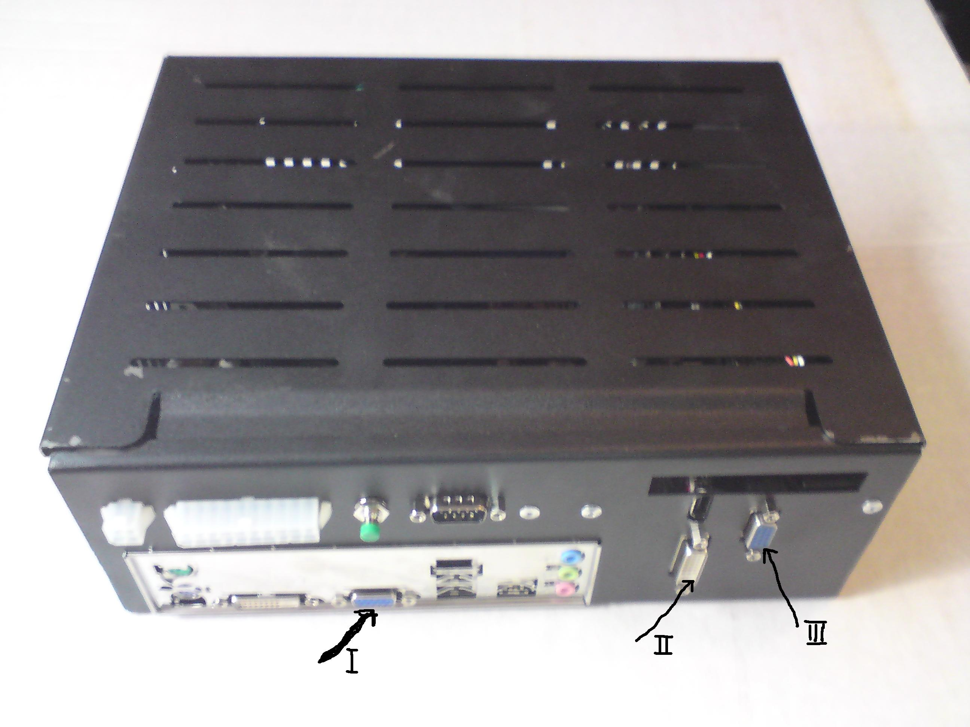
Picture № 1

Note: Connecting of the embedded computer system is analogous to connecting of Igrosoft. Positioning of the controller (of the embedded computer system) is the same as at connecting of the PCB Igrosoft.

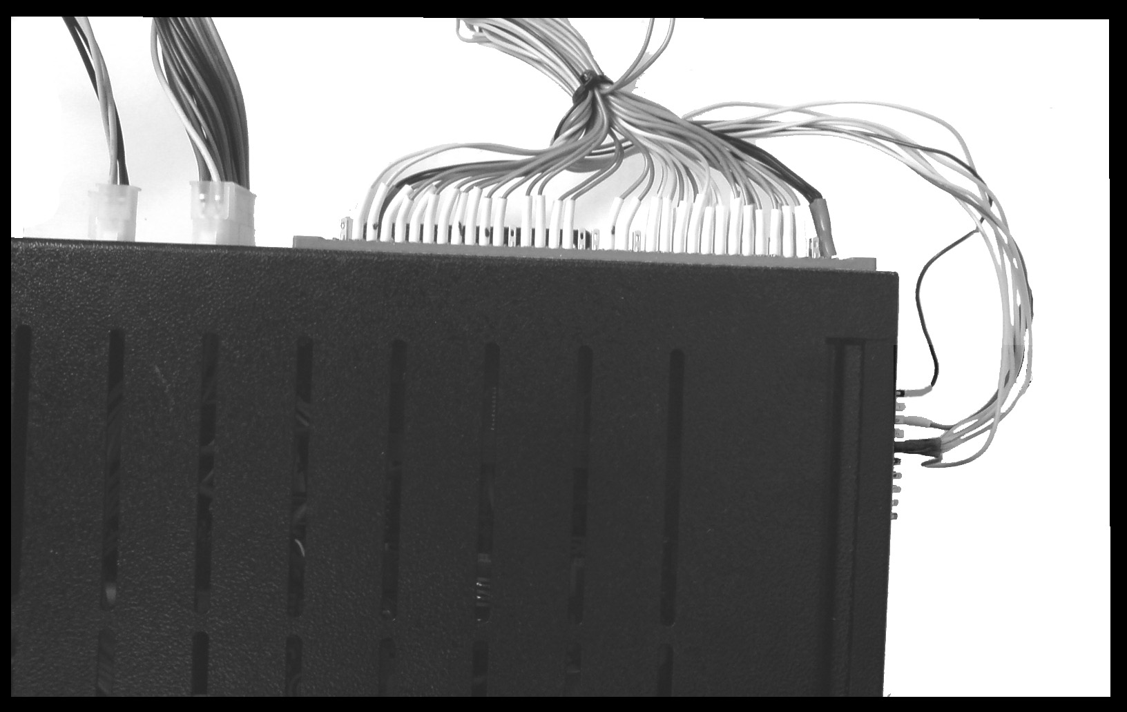

Connecting of the bill acceptor according to the protocol

General information
Recommended type of the bill acceptor: MFL-0386 (validation head MFLV-2110, power interface FLP-1710). Such bill acceptor (with power interface 1710) is connected to the embedded computer system with a special interface cable, which includes integrated circuit of adapting with levels of informational signals. Bill acceptors with power interface 2810 are connected to the embedded computer system with the interface cable without the microcircuit of adapting (power interface 2810 corresponds to the standard COM-port of the embedded computer system).

Pins for connector of the bill acceptor

Exterior image
1
6
7
12

Functionality of outputs
Contact | Purpose
1 | +12 V
2 | M.RES
3 | +12 V (INTERFACE)
4 | GND
5 | LED+
6 | NC
7 | GND
8 | TXD
9 | RXD
10 | NC
11 | LED-
12 | NC

Pins for COM

Exterior image

On the connector, switched to the embedded computer system

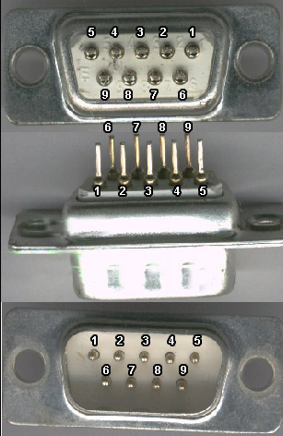
On the embedded computer system

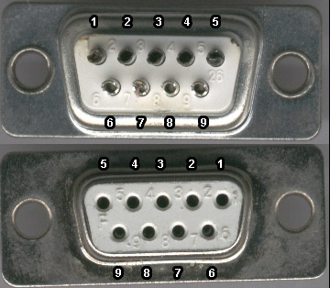

Functionality of outputs
N of output | Name | Character of signal | Signal
1 | DCD | Input | Data carrier detect
2 | RxD | Output | Transmit data
3 | TxD | Input | Receive data
4 | DTR | Output | Data terminal ready
5 | GND | - | Ground
6 | DSR | Input | Data set ready
7 | RTS | Output | Request to send
8 | CTS | Input | Clear to send
9 | RI | Input | Ring indicator

Connector on the motherboard

RRXD1
DDTR#1
DDSR#1
CCTS#1
DDCD#1
TTXD1
GND
RRTS#1
RRI#1
1
2
9

Correspondence of the connector on the motherboard to exterior connector
Connector contact on the motherboard | Contact of the exterior connector
1 (DDCD#1) | 1 (DCD)
2 (RRXD1) | 2 (RxD)
3 (TTXD1) | 3 (TxD)
4 (DDTR#1) | 4 (DTR)
5 (GND) | 5 (GND)
6 (DDSR#1) | 6 (DSR)
7 (RRTS#1) | 7 (RTS)
8 (CCTS#1) | 8 (CTS)
9 (RRI#1) | 9 (RI)
10 - | -

(All the contacts match each other)

Connecting of the bill acceptor (power interface 1710) to the embedded computer system
The converted interface cable from the bill acceptor ICT A7 is used for connecting.

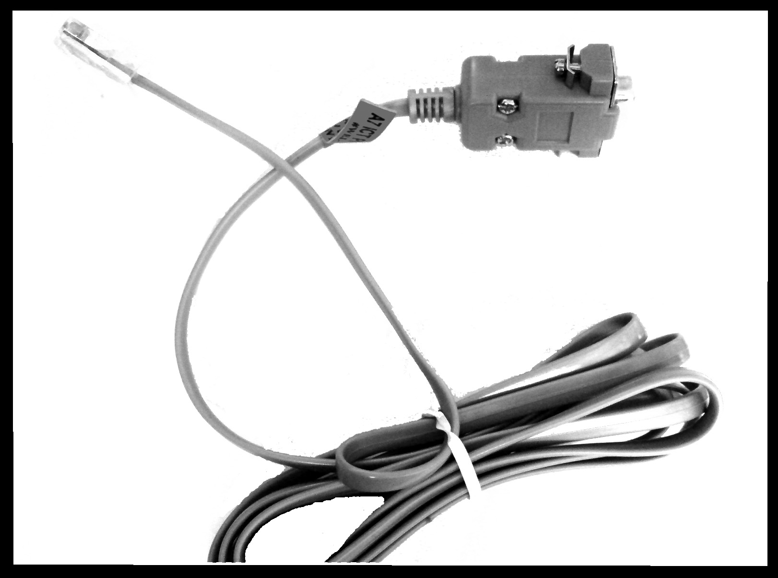

The scheme of connecting of the interface cable and power for the connector is shown below. ATTENTION! The bill acceptor connector is shown from the side of wires.

Bevel
Ground
+5 V
+12 V
Black
White
Blew
Red
Interface cable
1
ATTENTION! For some models of the interface cable power +12 V instead of +5 V is required.

Functionality of wires of the interface cable A7

Pin1 | GND | Blew
Pin2 | TXD2
Pin3 | RXD2
Pin4 | Program
Pin5 | Reset
Pin6 | VCC | Red
Pin7 | RXD1 | Black
Pin8 | TXD1 | White

Note: For connecting any other bill acceptor according to the protocol the same interface cable А7 can be used. For this the connector for ICT A7 is disposed, the power connector is added and an adapting pipe for a necessary bill acceptor. Connecting of the bill acceptor with impulse is possible (see. 72-pin connector).

In the menu of the embedded computer system necessary settings for the bill acceptor are chosen. For data saving it is necessary to make reset by means of switching off power.

