Manual.
How to use Protocol Translator for bill acceptors.

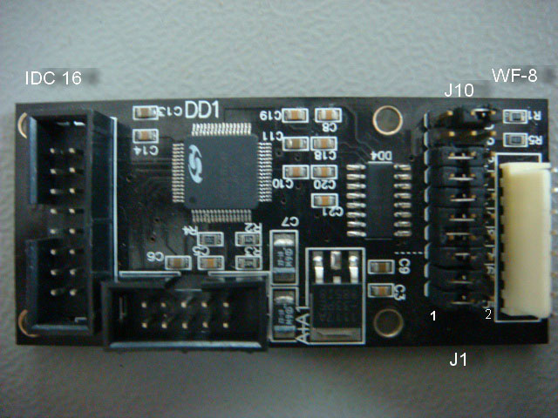

1. Bill acceptor ID003, CCNET or other must be connected to the connector IDC-16.
1 | + 12В
2 | GND
11 | RX of a bill acceptor
15 | TX of a bill acceptor

2. A corresponding part (gaming board, terminal, etc.) is connected to the connector WF-8, and also power voltage must be switched on.

If it is used in the Pulse regime

1 | +12V from the power source
2 | +12V from the power source
3 | +12V from the power source
4 | GND
5 | GND
6 | GND
7 | NC
8 | Impulse output

If it is used in the CCNET – ID003 regime, then it must be connected as follows:

1 | +12В from the power source
2 | +12В from the power source
3 | +12В from the power source
4 | GND from the power source
5 | GND from the power source
6 | GND to the exterior device
7 | Rx of the device, which works at the protocol (gaming board, terminal, etc.)
8 | Tx of the device, which works at the protocol (gaming board, terminal, etc.)

3. Choosing the protocol at output of the translator is realized with a help of crosspieces J9, J10.

J9 | J10 | Protocol
2 | 1 | ID003 - impulse
1 | 2 | CCNET - impulse
1 | 1 | CCNET - ID003

It is advisable to set the crosspieces in advance, and to connect the power after that.
Given you change position of the crosspieces while working, there won’t be any effect. A variety of crosspieces J9, J10 may differ from the set of protocols in the translator.

4. Choosing the protocol at output of the translator (TTL or RS-232) is realized with a help of crosspieces J1 – J8.

J1 – J4
1 | RS-232
2 | TTL (to use for bill acceptors NV9)

J5 – J8
1 | RS-232 (to use for connecting to a PC)
2 | TTL

- Determining of the table of bills and of a divisor of impulses for translator into impulse
The translator determines the table of firmware of the bill acceptor automatically. It takes the minimal value from the table. If it is less than 10, then impulses are given one to one. 10 impulses are given to 10 money unities. If the least value is more than 10 and it can be divided into 10 without rest, then impulses are given 1 to 10 (it will be like that for Russian firmware). For 10 money unities 1 impulse is given. If this number can’t be divided into 10, for example 25, impulses are given one to one.

Almost all sets of firmwares for a bill acceptor Cash Code come within such scheme, with the exception of Estonia and Netherlands. The minimal bill there is 10, and the next one is 25. Refer to JCM ID003.pdf Appendix E.
- Limits of the translator CCNET-ID003
6.1. Prohibition of bills by one is not supported. If even one bill is permitted in ID003, then CCNET will be accepting all of them.
6.2. Commands Security, Optional, Direction are not supported. They are being processed correctly, but CCNET will work as default.
6.3. Digital values of channels are accounted from the table of firmware CCNET to the table of firmware for ID003 correctly, but the country code will always be 39 (RUS).
6.4. As there are only 8 channels in ID003, while there are 24 of them in CCNET, only first 8 channels are used. If a bill comes via the channel 9 CCNET, then ID003 will recognize it as channel 8. Everything that will be more than 8, will be channel 8. And first 8 channels CCNET will correspond to first 8 channels ID003.

THE MOST IMPORTANT. The firmware works only in the regime of polling. This is a majority of games. But there are some ones which work at interruption from ID003. This regime is not supported yet.

